Level 1 Incident Investigation activity report
- Refresh yourself on the Human performance eLearn modules that introduces this topic:
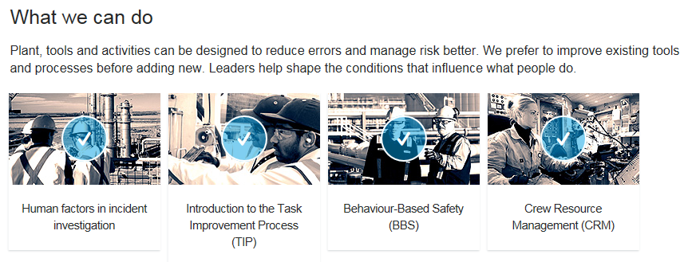
Go to the bottom of the module section and Download the related content and in particular the Human Factors Investigation Toolkit, shown below:
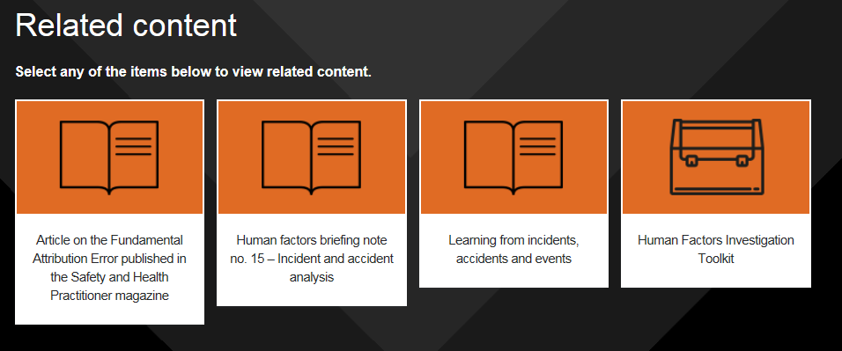
- Read and review the Human Factors Investigation Toolkit and the component tools. You will need to select, at least, one of these behaviour analysis tools (e.g. “Basic Analysis Tool”, “5 step approach”) to apply as part of the learning activity, see below (D).
- Read the “IOGP Guide: Demystifying HF in investigations”, HSE List of Performance Influencing Factors.
- Identify if your company has a behaviour analysis or human error analysis tool available.
- Complete the report template below.

1 | Lead or participate in an incident investigation OR If there is no investigation available, look into a near miss or a dangerous occurrence, then:  Apply one or more of the behaviour analysis tools to behaviours identified during the investigation. You need to choose from the “Basic Analysis Tool” or the “4 Step Approach” or you could use your company’s approach if it is equivalent to the methods in the Toolkit).
1a | Describe the incident investigation you led or participated in?  OR describe the near miss or dangerous occurrence you looked into?
Add your answer: | <Describe the incident, near miss or dangerous occurrence>
1b | What tool/s from the HF Toolkit did you apply to analyse the behaviour/s?
Add your answer: | Tick which of the following you chose to apply:  □ “Basic Analysis Tool” or  □ “4 Step Approach” or  □ Your company’s human error analysis tool equivalent approach> Baker Hughes tool is available here: https://ge.box.com/s/9ijbr1yqhzcebp10jd9hen2fguw0t11c
Add a screenshot or annotated print of one completed tool | <Add an image showing one of the tools used and how you have completed it>
1c | Provide a summary of the outputs from applying the tool/s.
 | Describe the behaviour related to 1a that you have you chosen to analyse?
Add your answer: | <Describe the behaviour you have chosen to analyse in an objective and neutral manner without attributing causes.  GOOD EXAMPLE: Worker was hitting the spanner with the hammer to unscrew the bolt. The worker missed the spanner and hit their hand with the hammer.>  BAD EXAMPLE: Worker put hands in the line of fire (not descriptive). OR Human Error. OR “Worker was complacent”
Behaviour occurs because it somehow helps individuals to complete their tasks and for various reasons is preferred over alternatives.
Discuss the context for the behaviour and its purpose. Work through the questions below and write 1-2 sentence-long answer to each.
 | What was the equipment and people the person interacted with?
 | What could they (not) see from their location/position?
 | What was their understanding at the time of what the correct action is to take (what information they had at the time)?
 | What did they NOT know at the time of taking the action and why (what information they did not have)?
 | What was the advantage of taking this particular course of action in that particular manner in that particular context, location, positioning (why it made sense to them)?
 | Review how this task was performed in the (recent) past. Was there anything different?
 | Describe the difference between Work-as-Imagined and Work-as-Done.
 | Identify Factors which influenced behaviour (PSFs), who contributed to those PSFs and why those PSFs were in place
 | PSFs | Who contributed to this PSF | ORGANISATIONAL FACTORS (why the PSF was in place) | Corrective actions for each PSF identified | Corrective actions for each organisational factor identified
 | <delete blue guidance text and replace it with your replies).  PSF Example 1:  Correct tool not available. | Supervisor did not make the request for the tool in advance. | Procurement processes did not involve the supervisor and workers in defining what’s needed for the job. | Redesign the activity to eliminate the need for manual unscrewing of the bolts. | Modify the process to involve end users in defining requirements  Train procurement department on the new procedure  Integrate the new procedure into the competency management system
 | PSF Example 2:  Procedure unworkable in practice. | Engineer wrote the procedure based on a technical drawing and didn’t test it in the field. | No process in place to test the procedure in the field with the operator. | Rewrite the procedure based on Walk-Through Talk-Through (WTTT) with the operator. | Integrate WTTT with the procedure development process.  Train engineers on WTTT.  Integrate WTTT into the competency management system for engineers and workers.
 | 3 |  |  | Remember to apply the hierarchy of controls http://bit.ly/2Oyfivj
 | 4
 | 5

You need to answer the three questions below if you wish to obtain an HP Level 1 Certificate from the Chartered Institute of Ergonomics And Human Factors. Answers to those questions are part of the online evidence submission form and your answers will be used for automated quality screening. You may reuse the content from the table above.
What did you do in order to carry out and complete the activity?- Min 100 words
…

What did you find out during the activity? – Min 100 words
…

What have you learned from this activity that will help you do your job better? – Min 100 words
…

